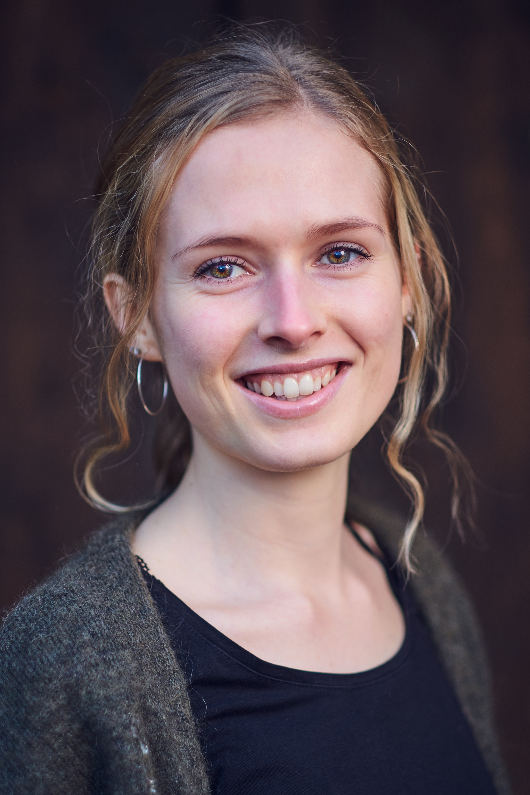 |  | Caroline huus  Actress
about me:  My name is Caroline Huus and I am a 20-year-old actress.  I am Norwegian and was born in Norway, however, I’ve spent parts of my childhood in Denmark and Kenya. As a result of living in different parts of the world, I’ve been privileged enough to develop my skills through learning from various cultures and people.  contact info:  PHONE NUMBER:  +47 405 82 745  WEBSITE/BLOG:  https://huuscaroline.wixsite.com/website  MAIL:  huus.caroline@gmail.com |  | appearance:  Hair: Blonde  Eyes: Green brown  Height: 164 cm  Nationality: Norwegian  skills:  Languages: I speak fluent Norwegian, Danish and English  Hobbies: Traveling, drawing/painting, running, knitting/crocheting, baking/cooking  Personality Traits: Perfectionistic, positive, effective, adaptable,  experience:  Tours: Multiple performance tours around Denmark with the Danish Pentecostal Bible College  Drama in Church and at Schools: I have created and performed many plays and dramas in churches and at schools in Denmark, Norway, Romania, Kenya, Czech Republic, India, Kuwait, etc.  Exam: Acting exam at Sandefjord Videregående Skole (Norway)  Theater productions: The Sound of Music, The Importance of Being Earnest, Maria Full of Grace

